


Srishyla Educational Trust®

GM UNIVERSITY
(Established under the Karnataka State Act No.19 of 2023) Post Box No.4, Davanagere - 577006

Project Based Learning Semester: III
(UE24CS2306)
PBL Report

“TITEL OF THE PROJECT”
TRAVEL PLANNING APPLICATION

Section- "AI1B"
Submitted By

MOHAMMAD SULTAN MOMIN - U25E01AI068
NOOTAN KUMAR K - U25E01AI084
ROSHAN D N - U25E01AI104
MOHINUDDIN HASSAN - U25E01AI073

PBL Coordinator Guide

Mr. MOHAMMAD ZEESHAN M Ms. BHOOMIKA
Asst. Professor Asst. Professor
Dept. of AIML Dept. of AIML

CONTENTS

S.No. | Title | Page No.
1 | Abstract | 1
2 | Introduction | 2
3 | Problem Statement | 3
4 | Objectives | 4
5 | Software Components Required | 5
6 | Methodology | 6

1. ABSTARCT

This project showcases the frontend development of a Travel Planning Application using core web technologies—HTML, CSS, and JavaScript—alongside Canva for visual design elements. The application is designed to assist users in organizing their travel experiences through an interactive and user-friendly interface.

Key features include itinerary creation, budget tracking, booking overview, and local discovery modules. The layout is structured with semantic HTML, styled using responsive CSS for cross-device compatibility, and enhanced with JavaScript to enable dynamic interactions such as form validation, tab switching, and real-time updates.

Visual assets like icons, banners, and UI mockups are crafted in Canva to maintain a cohesive and appealing design language. The project emphasizes modular code structure, accessibility, and performance optimization, serving as a foundation for future backend integration and scalability.

This frontend implementation provides a practical and visually engaging solution for travelers seeking to streamline their planning process.

2. INTRODUCTION

In today’s fast-paced world, travel has evolved from a luxury to a lifestyle—whether for leisure, business, or exploration. Yet, planning a trip remains a complex and often overwhelming task, involving multiple layers of decision-making, coordination, and organization. This project introduces a Travel Planning Application, a web-based solution designed to simplify and enhance the travel planning experience through a visually engaging and interactive frontend interface.
Built entirely using HTML, CSS, and JavaScript, the application focuses on delivering a seamless user experience without relying on external frameworks or libraries. It leverages the power of pure web technologies to create a responsive, intuitive, and aesthetically pleasing platform that guides users through every stage of their journey—from selecting destinations to managing budgets and discovering local attractions.
To elevate the visual appeal and maintain design consistency, Canva is used to create custom graphics, icons, banners, and UI mockups. These assets help establish a cohesive travel-themed aesthetic that evokes excitement, adventure, and clarity. The interface is designed with a mobile-first approach, ensuring accessibility across devices and screen sizes.
The application is divided into key modules:
- Booking Overview: Displays flight, hotel, and transport details in a clean dashboard format.
- Budget Tracker: Helps users manage expenses with simple input forms and visual summaries.
- Local Discovery Panel: Showcases attractions, restaurants, and cultural highlights tailored to the destination.
This project not only demonstrates technical proficiency in frontend development but also showcases creativity in user interface design and problem-solving. It serves as a foundation for future enhancements such as backend integration, user authentication, and API connectivity. Ultimately, the Travel Planning Application aims to be a digital co-pilot for modern travelers—making trip planning as enjoyable and stress-free as the journey itself.

3. PROBLEM STATEMENT

Planning a trip involves juggling multiple tasks—booking, budgeting, itinerary creation, and local discovery—often across different platforms. This can be time-consuming and confusing, especially for non-technical users.
This project aims to solve that by building a simple, responsive, and visually appealing travel planning interface using HTML, CSS, JavaScript, and Canva. It offers core features like itinerary management, budget tracking, and booking overview—all in one place, without relying on backend systems or external libraries.

4. OBJECTIVES

The primary objective of this project is to design and develop a visually appealing, responsive, and user-friendly Travel Planning Application using only HTML, CSS, JavaScript, and Canva. The application aims to simplify the travel planning process by offering essential tools and features within a clean, intuitive interface that works seamlessly across devices.

Specific Objectives:

🧱 Build a modular frontend architecture using semantic HTML for structure, CSS for styling, and JavaScript for interactivity—without relying on external frameworks or libraries.

🎨 Create a cohesive visual design system using Canva to produce custom icons, banners, and UI elements that reflect the theme of travel and exploration.

📅 Implement an itinerary builder that allows users to create, view, and edit daily travel plans with ease.

💰 Develop a budget tracking module to help users input expenses, monitor spending, and stay within their travel budget.

🏨 Design a booking overview section to organize flight, hotel, and transport details in a clear and accessible format.

📍 Integrate a local discovery panel showcasing attractions, restaurants, and cultural experiences tailored to the user’s destination.

📱 Ensure responsive design for optimal performance on mobile, tablet, and desktop devices using media queries and flexible layouts.

⚙️ Add interactive features such as tab switching, form validation, and dynamic content updates using vanilla JavaScript.

🧪 Focus on usability and accessibility, ensuring the interface is easy to navigate for users of all backgrounds and abilities.

🚀 Demonstrate frontend development proficiency by delivering a complete, functional, and aesthetically pleasing travel planning tool that can serve as a foundation for future enhancements.

5.METHODOLOGY

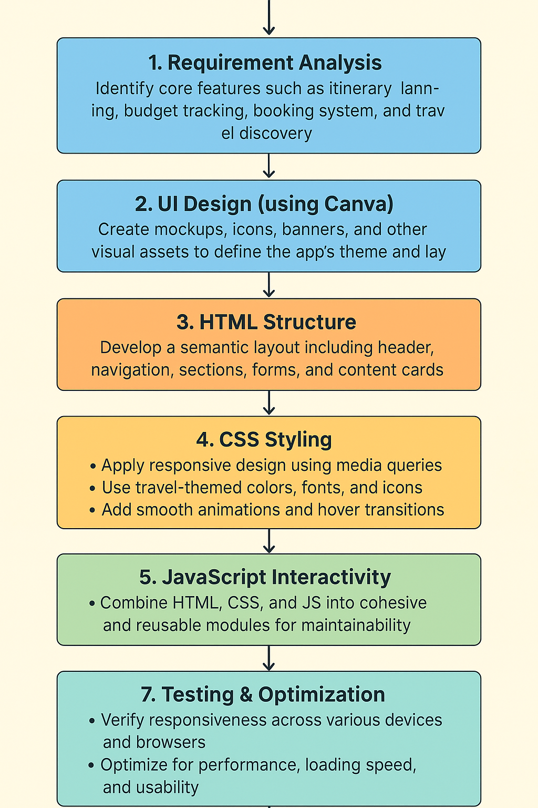

6.SOFTWARE AND HARDWARE REQUIREMENTS

1. Code Editor

🔧 Visual Studio Code (VS Code) – Recommended for writing and organizing HTML, CSS, and JavaScript files.

2. Web Browser

🌐 Google Chrome, Mozilla Firefox, or Microsoft Edge – For testing and debugging your application.

3. Design Tool

🎨 Canva – Used to create UI mockups, icons, banners, and other visual assets.

4. Version Control

🗂️ Git – For tracking changes and managing code versions.

🌍 GitHub – To host your project repository and collaborate (optional but useful).

5. Local Server (Optional for Testing)

⚙️ Live Server Extension (in VS Code) – Automatically reloads your app when you save changes.

6. Browser Developer Tools

🛠️ Built-in DevTools in Chrome/Firefox – For inspecting elements, debugging JavaScript, and testing responsiveness.

